How the human biological clock responds to light
In a study of the human biological clock, researchers from the LUMC investigated if and how our internal clocks respond to different colours of light. Their findings can help improve light therapy, advice concerning nocturnal lights as well as the use of electronic screens...
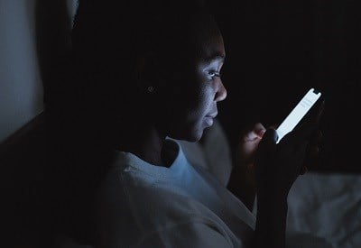
... and adjustments to work shifts.
By using MRI scans to identify and image the human biological clock located in the brain, Johanna Meijer, Professor of Neurophysiology, Robin Schoonderwoerd, PhD candidate at the Department of Cell and Chemical Biology of the LUMC, and colleagues discovered how different colours of light affect our internal clock. Their findings have been published in PNAS.

The biological clock sees colour
Almost all organisms on Earth have an internal biological clock that contributes to their fitness and health. The biological clock regulates the circadian cycle - a natural process that is synchronized to daylight and regulates our sleep-wake cycle, repeating approximately every 24 hours. “Although general consensus is that blue light stimulates our biological clocks the most, we found that other colours can affect the clock as well. This means, for example, that the use of blue light filters in the evening is not sufficient to stop our sleep rhythm from being disturbed!” says Meijer.

Smallest brain area ever registered
Imaging the biological clock has been an unprecedented technical achievement due to how extremely small the size of this brain area is. Meijer notes: “It is only 2 mm3. By using a 7 Tesla MRI scanner in combination with new analytical methods, we managed to increase the spatial resolution of this area sufficiently to finally measure it.” This makes the biological clock the smallest area of the brain ever to be directly measured with MRI.

What’s next?
The work of Schoonderwoerd, Meijer and colleagues offers new insights into the effect of light on the biological clock. For instance, current strategies to prevent their harmful effects in the evening must be revised. “Because we now know that that multiple colours can affect our internal clock, we advise to also dim the light in the evening, instead of just filtering blue light out. The good news is this works the other way around: all colours are effective to stimulate the clock during the day, which is especially important for nursing homes, clinical settings and even for children’s bedrooms.”

